PYTHON PROJECT

MAXWELL-BOLTZMANN DISTRIBUTION

TEAM MEMBERS:

ANIKET KUMAR GIRI(BT20CSE089)

YASH OJHA(BT20CSE063) PRANESH AJAY GHADGE(BT20CSE095)

ANIKET B AGRAWAL(BT20CSE001)

SHUBH GUPTA(BT20CSE29)

PROJECT DESCRIPTION:

THE PROGRAM WILL ANALYSE THE BEHAVIOUR OF AN IDEAL GAS AND PLOT THE CORRESPONDING MAXWELL BOLTZMANN DISTRIBUTION CURVE WITH RESPECT TO: frequency density Vs speed of the gas particles

IDEAL GASES:

An ideal is a theoretical concept having following properties:

* It is composed of many randomly moving point particles
* These particles have no interactions between them
* They follows ideal behaviour
* They follows ideal gas laws (PV = nRT)
* Generally, a gas behaves more like an ideal gas at higher temperature and low pressure

MAXWELL BOLTZMANN DISTRIBUTION:

* The Maxwell Boltzmann is a particular probability distribution used for describing the particles speed in idealized gases.
* The particles move freely inside a stationary container without interacting with one another, except for very brief [collisions](https://en.wikipedia.org/wiki/Collision) in which they exchange energy and momentum with each other or with their thermal environment.
* The energies of such particles follow what is known as [Maxwell–Boltzmann statistics](https://en.wikipedia.org/wiki/Maxwell%E2%80%93Boltzmann_statistics), and the statistical distribution of speeds is derived by equating particle energies with [kinetic energy](https://en.wikipedia.org/wiki/Kinetic_energy).

DISTRIBUTION FUNCTION:

Assuming the system of interest contains a large number of particles, the fraction of the particles within an infinitesimal element of three-dimensional velocity space, {\displaystyle d^{3}v}d3v, centred on a velocity vector of magnitude {\displaystyle v}v, is {\displaystyle f(v)\,d^{3}v}f(v)d3v:

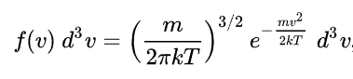

Where,

m = mass of the gas particle

k = Boltzmann-constant

T = thermodynamic temperature

f(v): probability distribution function

CURVE: Probability density Vs speed

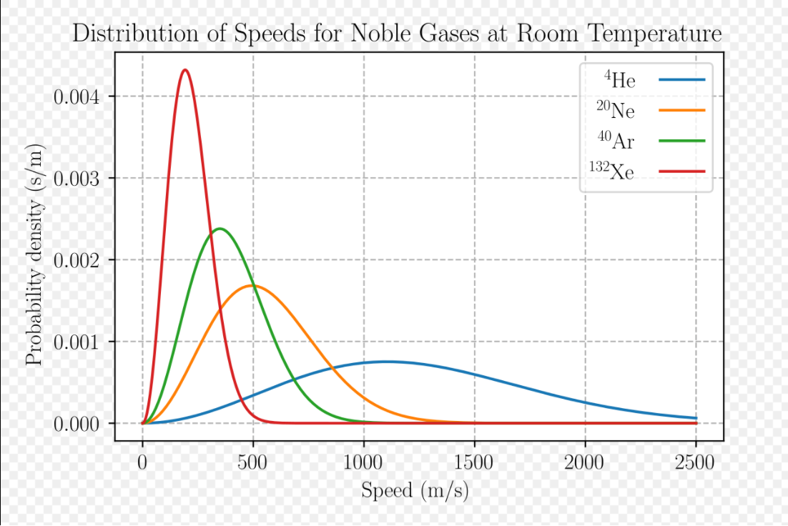

The speed probability density functions of the speeds of a few [noble gases](https://en.wikipedia.org/wiki/Noble_gas) at a temperature of 298.15 K (25 °C). The *y*-axis is in s/m so that the area under any section of the curve (which represents the probability of the speed being in that range) is dimensionless.

Python code Description:

PLOT: frequency Vs speed



Thank You